


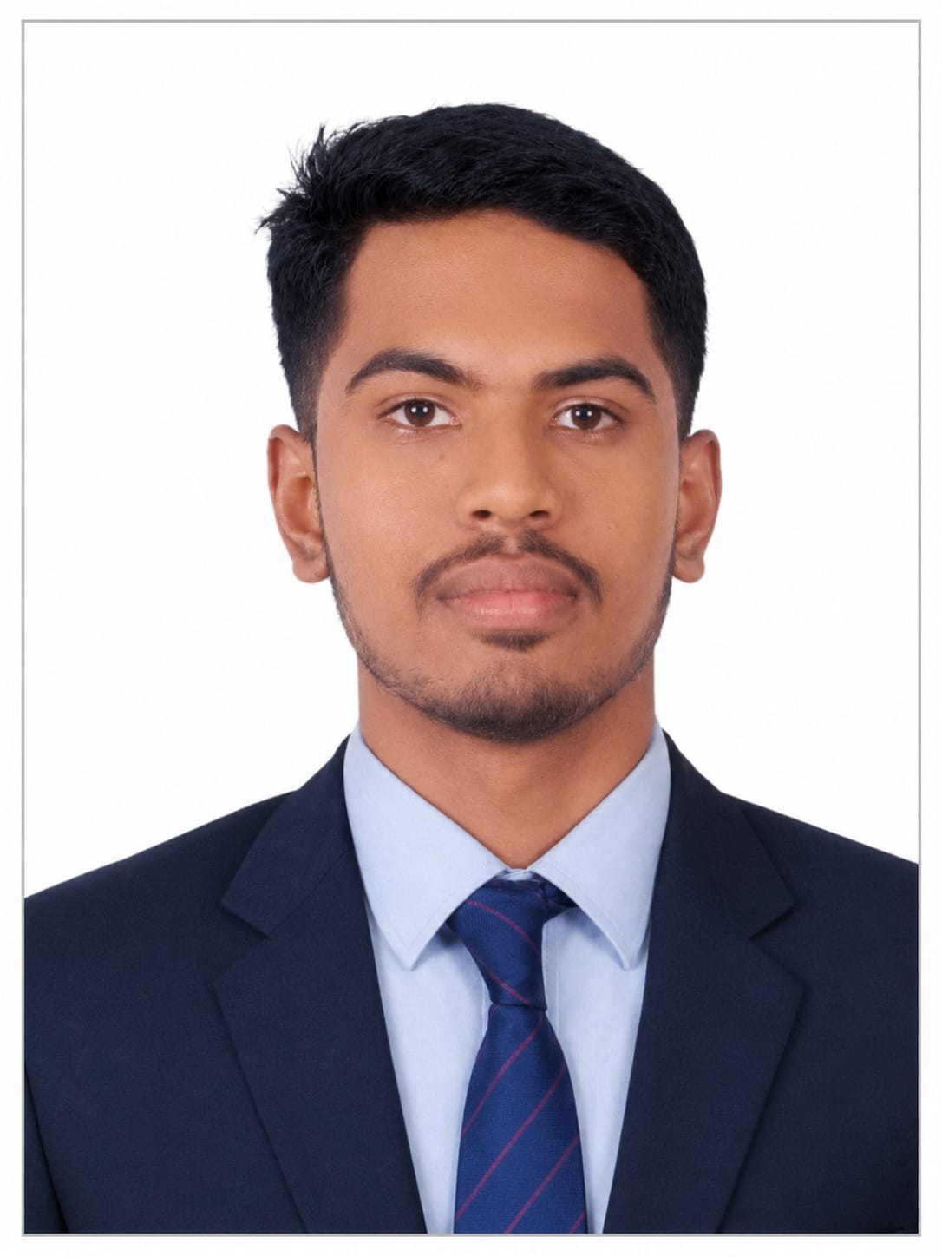

Education
Diploma in Computer science & Engineering
Hindustan Electronics Academy,

SSLC (10th)
Florence public school,
State Board,
2024

Skills

- Coding
- SQL
- Debugging
- Microsoft Office
- Spreadsheets

+91 8431357481
anjankumarv4@gmail.com
www.linkedin.com/in/anjan-kumar-v-20ab40437

Contact

ANJAN KUMAR V

CAREER OBJECTIVE

To begin my career in a reputed organization where I can apply my skills and knowledge gained during my diploma and grow professionally.

TECHNICAL SKILLS
- Basic knowledge of Software Tools
- Knowledge of Computer Network, Computer Hardware & Maintenance Application
- MS Office Word, Excel, PowerPoint
- HTML

CERTIFICATIONS
- MySql
- CyberSecurity

EXTRA-CURRICULAR ACTIVITIES
- Donated Blood in the Blood Camp
- Member of IIC(Innovative Institution Council)

PERSONAL PROFILE
- Father Name: Venkatesh
- Date of Birth: 3rd of June 2008
- Gender: Male
- Language known: English, Kannada, Hindi, Telugu
- Nationality: Indian
- Hobbies: Loco-pilot, Cricket
DECLARATION
I hereby declare that the above-mentioned information is true and correct to the
best of my knowledge and belief.
Date: 09/09/2026 Signature
Place: Bangalore Anjan Kumar V

